Simply Fit Homepage

User will first land on this page

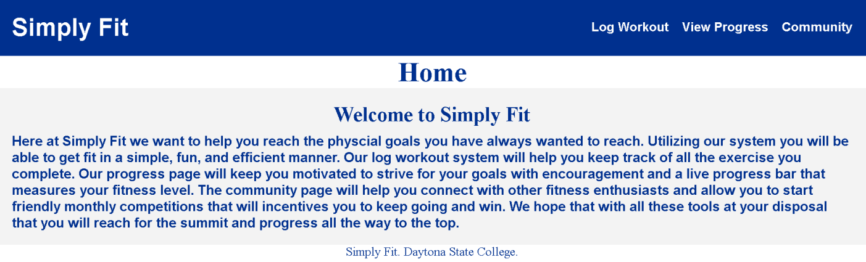

Simply Fit Community Page

User clicks “Community” from the menu at the right top side

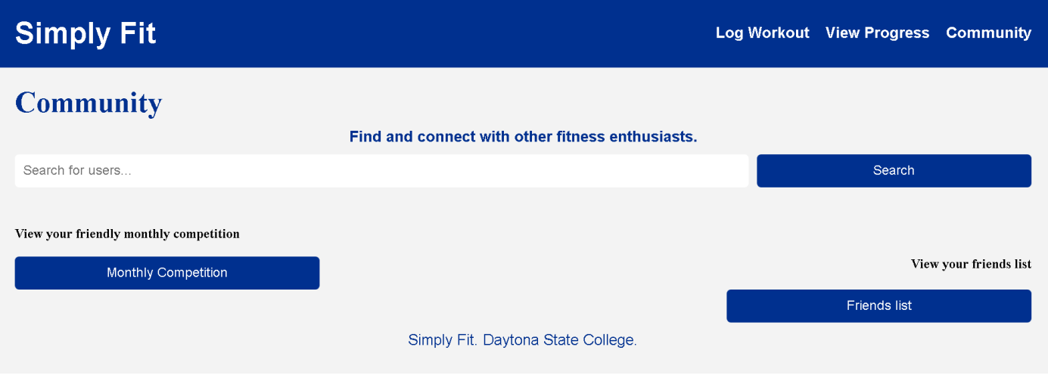

User click “Friends List”

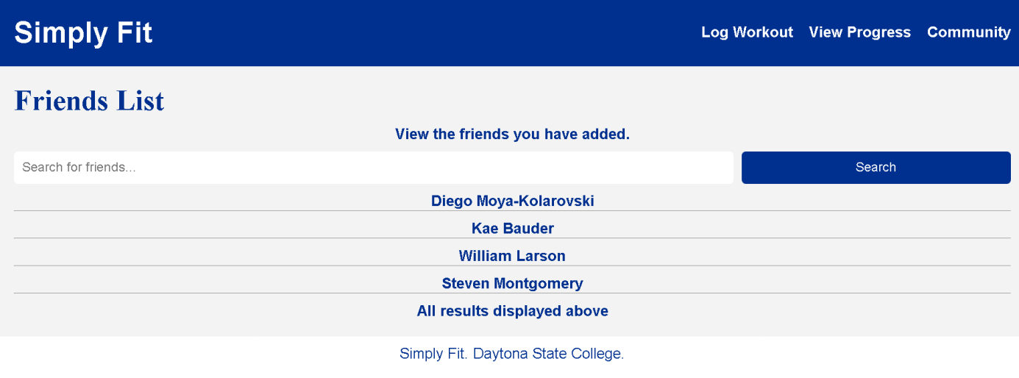

User enters friend’s name in “Search for friends…” box

When “Monthly Competition” is clicked

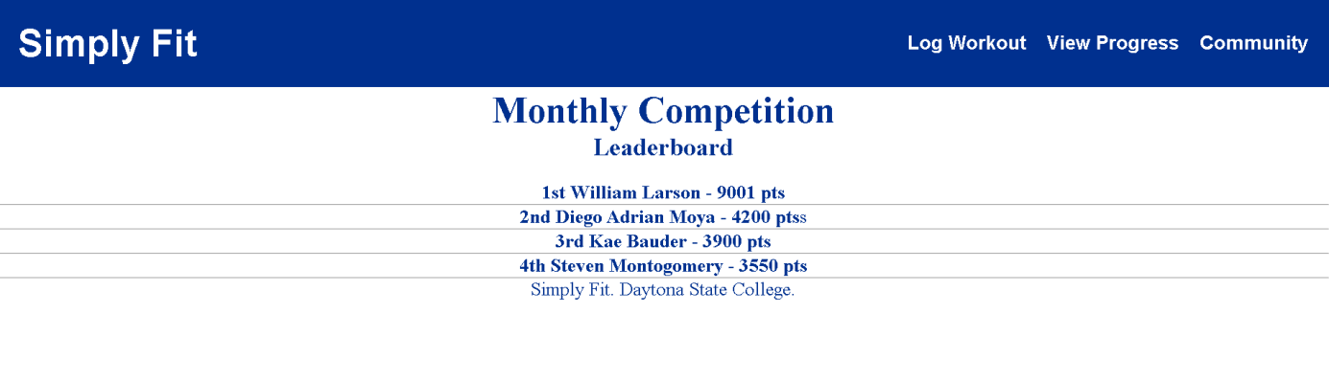

**Log Workout Page**

User click Log Workout Menu

User enters Exercise Name, Sets, Reps, Duration

Click Log Workout button when ready

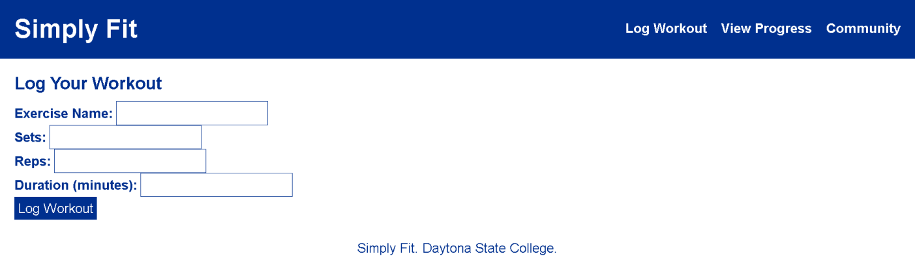

View Progress page

User clicks “View Progress” menu

